
Name:

11 Physics
Vectors and Errors
Topic Test 2015

Score: _________ / 50 ______________%

TIME ALLOWED FOR THIS TEST
Working time for this paper: 50 minutes

MATERIAL REQUIRED OR RECOMMENDED FOR THIS TEST

This question and answer booklet
Physics Formula & Constants Sheet
Pens, pencils, eraser, rule, Mathaid or Math-o-Matt
Scientific calculator

INSTRUCTIONS
Answer all questions and write answers in the spaces provided.
Numerical answers should be evaluated with three significant figures unless otherwise stated and given in scientific notation.

1. A swimmer’s arms provide a force of 80 N directed toward the north but there is an eastward force of 60 N caused by a strong tide. What is the net force on the swimmer?
[4]

2. The collision of two snooker balls, A and B, as shown from above, is as follows.

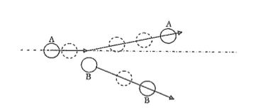
Initially, ball A is moving to the right at 0.45 m s⁻¹ and ball B is stationary. After a glancing blow between the balls, ball A moves off at 0.25 m s⁻¹ at an angle of 15° from its original path.

Calculate the change in velocity of ball A.
[6]

3. Whenever an electric power line follows a bend in the road, a guy wire is used to prevent the pole from leaning over. A guy wire 6.00 m long extends from the top of a telephone pole to a point on the ground 3.00 m from the base of the pole. The tension in the wire is 1200 N.

a) What is the horizontal force on the pole?
[3]

b) Briefly explain why the guy wire also makes the pole more secure in the ground.
[2]

4. Mr McKern has been asked to fix the window in 1LS6. A vertical force of 60 N is required to raise the window sash. However, to raise the window, Mr McKern needs to use a pole at an angle due to the proximity of Mr Hughes’s ego. (Mr Hughes gets very grumpy if his desk is moved). How much force must Mr McKern exert if the force is applied by a pole that makes an angle of 40° with the window?
[4]
5. A train of mass 6000 kg travels up a hill at a constant speed to 10 m s⁻¹. There is friction between the train and the tracks equivalent to 10% of the weight of the train.
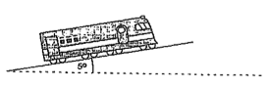

- What is the driving force that the wheels of the train are exerting on the track to keep the train travelling up the hill?
[5]

- What is the normal reaction of the track?
[3]

6.
- In what position is the tension the least in the arms of the weightlifter shown in the figure below? Explain briefly.
[2]
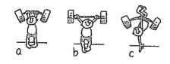

- Why is less force required to push a barrel up a sloping ramp, as shown in the figure below, rather than to lift it vertically?
[3]
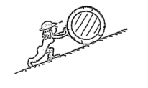

7. Give the following numbers in scientific notation to the number of significant figures required.
[4]

Number | four significant figures | two significant figures
0.005 654 2
125.04
4 400 042
0.000 000 100 092

8. The mass of the earth is 6.0 x 10²⁴ kg, and its volume is 9.883 x 10²¹ m³. Compute the density of the earth, where;

Density = mass / volume

and give the answer to the correct number of significant figures according to the data given.
[2]

9. A value for the diameter of a large ball is required. The ball is placed upon a metre rule in order to assess its diameter. An observer notes that one end of the diameter is at the 35 cm mark and the other is at the 78 cm mark.

Calculate the diameter of the ball, including the uncertainty, if the ruler divisions are in:

- centimeters, b) millimetres Show your working
[4]

10. The following formula was fundamentally involved in Millikan’s classic determination of the charge on an electron by the oil drop method. It is also the basis of a simple method of comparing the viscosities of two liquids by observing the terminal velocities of a steel ball as it falls through the two liquids being compared, in turn.
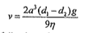

Given the following values,

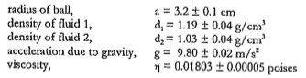

determine the value of:

- (d₁ – d₂), including the error,
[2]

- the terminal velocity (v), including the error.
[6]

END OF TEST ☺

